Using the GIS module from DHIS-2 to display indicators and data elements

# Overview:

The DHIS-2 platform has very user-friendly software that can be used to display values of Data elements and Indicators from the DHIS. The module is based on the Healthmapper software developed with support from WHO.

This software is used primarily for display purposes and has nice interactive features. For example if you display data from a high level of the hierarchy such as province, you can double click on a polygon and the software will automatically drill down to the next lower level in the hierarchy.

The GIS module is most useful for interactive analysis purposes as the user has fairly limited control over certain layout options, such as the format and placement of the legend, titles, and labels. Nevertheless, these maps can be saved and pasted or imported into documents and PowerPoint presentations.

For more sophisticated map layouts a software package like QGIS or ArcMap should be used.

The software produces 3 kinds of maps:

1. **Maps displaying data associated with polygons**, such as districts and sectors. Differences in values are displayed using different colors (sometimes called Choropleths)

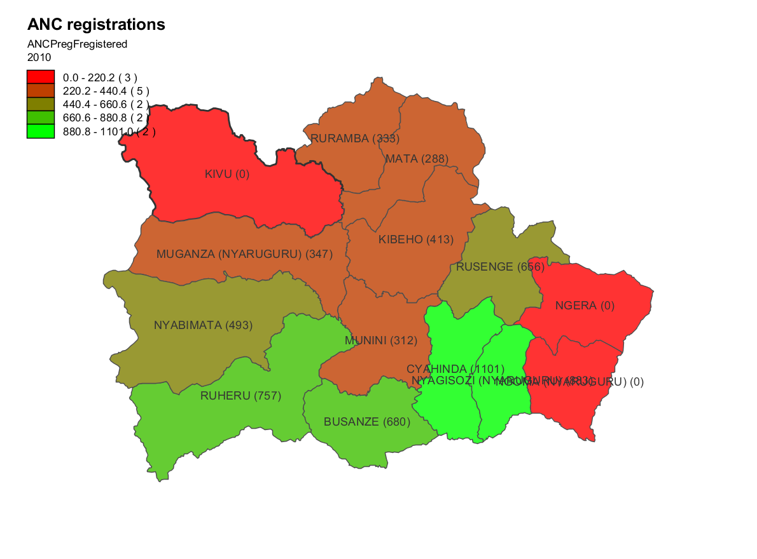

1. 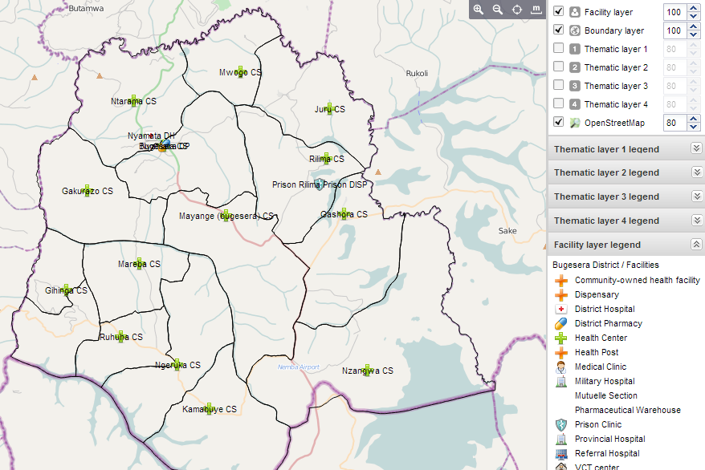**Maps displaying point data**, such as the locations of health facilities. Differences in values are represented by different size dots as well as different colors. Point layers can also be combined with polygon layers.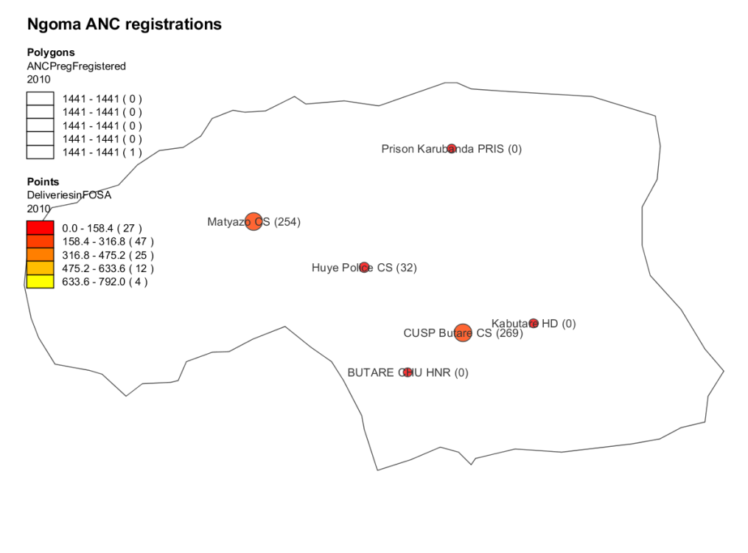
2. **Resource maps:** These show the locations of facilities by type. facility

There are detailed instructions about configuring the GIS module in the DHIS-2 user’s manual which is available electronically. These guidelines are designed to get users up and running quickly once the basic DHIS-2 platform has been set up.

# Step by step guidelines for creating thematic (choropleth) maps:

|  |  |  |
| --- | --- | --- |
| 1. Login to DHIS-2 |  | |
| 1. From the Services menu select GIS |  | |
| 1. You should see the following screen |  | |
|  | | |
| 1. From the map controls menu at the top of the map select the button with the number 1 to open the Layer one dialog box (you can create up to 4 layers by selecting 1, 2, 3 or 4). |  | |
| 1. To create a polygon map, fill in the Thematic layer form at the left side of the screen. This requires the following values:    1. Map value type: Indicator or data element    2. Indicator/Data element group: for example Malaria, MCH, etc…    3. Indicator/Data element: Select the specific indicator or data element that you wish to map.    4. Period type: maps can only display one time period at a time. This can is usually Month or Year for the data in the Rwanda data warehouse.    5. Period: select the corresponding period that you want to display    6. Legend type: Automatic or Predefined    7. Classes: how many groups do you want to break your values into    8. Method: this allows you to select the way you want to split up the different categories of your indicator values. Options are: Equal intervals, Equal group count or Fixed breaks (for fixed breaks enter cutoffs as comma separated values: 500,1000,2000).    9. Low color: this is the color that will be assigned to the lowest group    10. High color: this is the color that is assigned to the highest group (intermediate range colors will be automatically provide by the system Boundary: the name of the outer level that you want to display    11. Level: the level to which you want to display the data (for example, district or sector)    12. In the hierarchy below, select the Parent level you want to display. In this example: Rwanda (shows each district across all of Rwanda) | |  |
| 1. **Manage Favorites:** by clicking on the Favorites menu, you can display the screen at right. 2. You can search for favorites by typing part of the name or you can browse the existing favorites by pressing next or previous to go through the list. Click on the name of the favorite to display the chart. The buttons on the right of each chart title are:    1. **Edit** the details for the chart    2. **Update** favorite with the currently displayed data    3. **Share**this favorite with other users. Normally the only charts you see are the ones that you have created.    4. Add this favorite map to your dashboard.    5. **Delete** this favorite | |  |
| 1. **Using the map interactively:** If you want to analyze the data at different levels, you can right click on any polygon and select Drill down (to show more detailed breakdowns of the data) or Float up (to show the next level up in the hierarchy). You can continue to drill down until you reach the point level where data are displayed for each health facility. This is a very powerful tool for identifying the source or ‘hotspot’ for the geographic distribution of an indicator. | |  |
| 1. **Downloading the map:**Click on the Download menu at the top and enter a name for the map and select the type of graphic file to create (PNG or PDF). The title will appear at the top of the map and the legend will also be displayed. | |  |

|  |  |
| --- | --- |
| 1. To create a resource map showing the location of health facilities using data points, click on the iconin the main menu, this should display the following options:    1. Organisation unit group set: Normally you should select Type (for type of facility), the other group sets that might apply are “TB diagnosis and treatment facility type” and “Ownership”.    2. Organisation unit level/parent: for a resource map, you must select the “Facilities” level    3. Parent: here you can select Rwanda, a province or a district. If you select too large a parent, there will be too many points to display. |  |
| 1. **Select boundaries:** For a resource mapyou will also want to select certain boundaries – these are the administrative borders that are not linked to any data. This is done through the selecting the globe icon. After selecting it you should see the following    1. First select the organizational unit level (*Administrative unit*) for which you want boundaries displayed, such as the Sector – lower in the hierarchy than the Parent    2. Then select the parent or outer boundary, such as a the district (this should be the same as in the Facilities layer)    3. Press update |  |
| 1. If you want to display the names of facilities, click on the Facilities tab and select labels. This should show you the following dialog.    1. Select any changes to the font that you want and then click on Show/hide to toggle between turning labels on and off.    2. Close the dialog box to show the full map as in the example below. |  |
|  | |